**Wheatley Wildcats Battalion**

**Color Guard Participating in Honoring WWII Veterans**

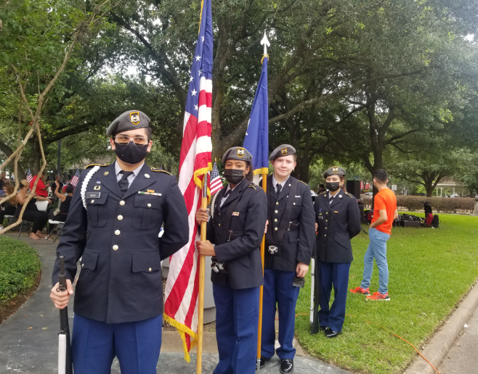

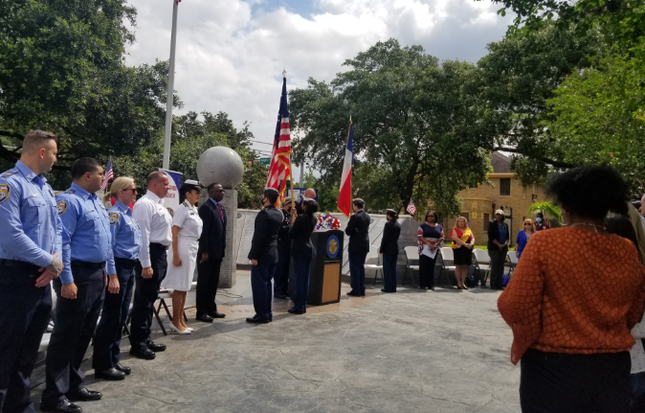

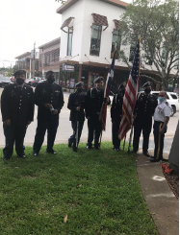

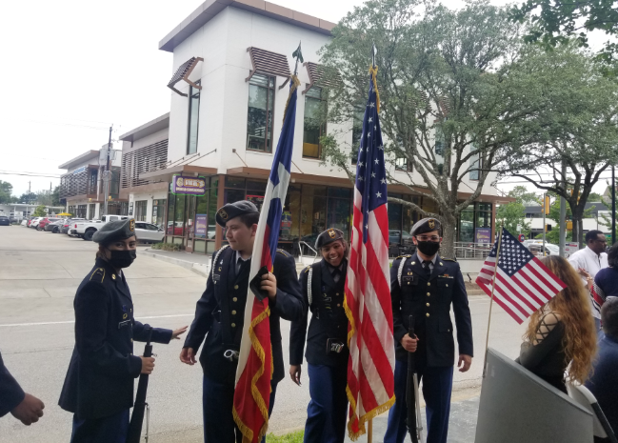

**Cadets Having a Great Meal After Ceremony**

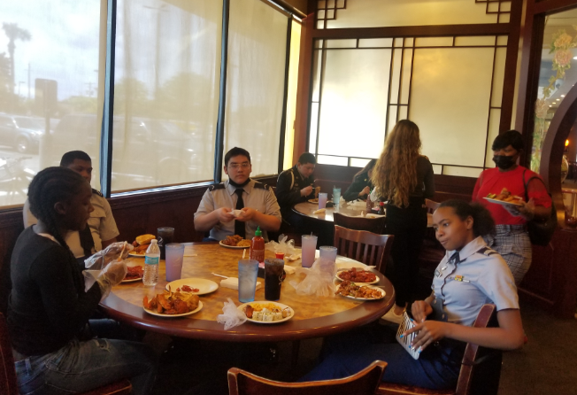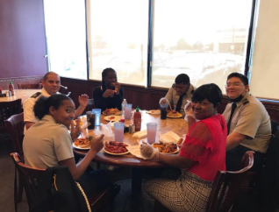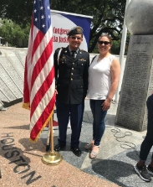

**Parents supporting our cadets during and after ceremonies**

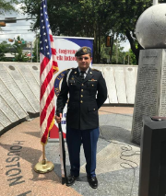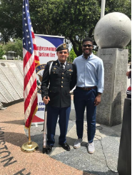

**Supporting our local Community is a privilege. Our Cadets are doing a great job at participating and making all these missions become reality. Their hard work and dedication are making a big difference.**

**Great job JROTC Wildcats Battalion!!!**